**Environmental Impact of Food Production**

SOURCE: Kaggle, from Our World in Data (OWID) - Science in 2018, Reducing food’s environmental impacts through producers and consumers. By J. Poore and T. Nemecek.

**Key Definitions:**

Land use change - kg CO2 - equivalents per kg product

Animal Feed - kg CO2 - equivalents per kg product

Farm - kg CO2 - equivalents per kg product

Processing - kg CO2 – equivalents per kg product

Transport - kg CO2 - equivalents per kg product

Packaging - kg CO2 - equivalents per kg product

Retail - kg CO2 - equivalents per kg product

Emissions are measured in carbon dioxide equivalents (CO2eq). This means non-CO2 gases are weighted by the amount of warming they cause over a 100-year timescale.

Greenhouse emissions (kg CO2 - equivalents per kg product)

Hypothesis: Will animal based food products have a bigger greenhouse gas impact?­­

For initial analysis, I choose to graph which food products had the highest emissions for the different categories of production. The first category was land change. The highest impact for land change was beef (beef herd). Some food products had a net negative impact for land change.

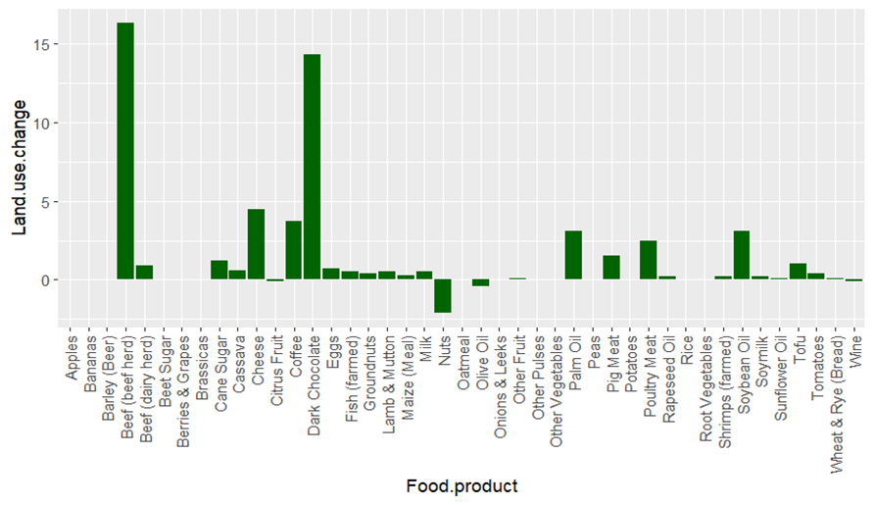

The highest emissions from animal feed were from pig meat. Obviously, there were values only for animal based food products. For farming it was beef (beef herd) by a large amount.

The highest impact for processing was tied for beef (beef herd) and palm oil.

The highest impact from transport was sugars (beet and cane).

The highest impact from packaging was coffee.

Cheese, soymilk, barley (beer), milk and tofu are tied for the highest emissions for retail.

Total emissions for all food production processes are below with beef (beef herd) being the highest by far.

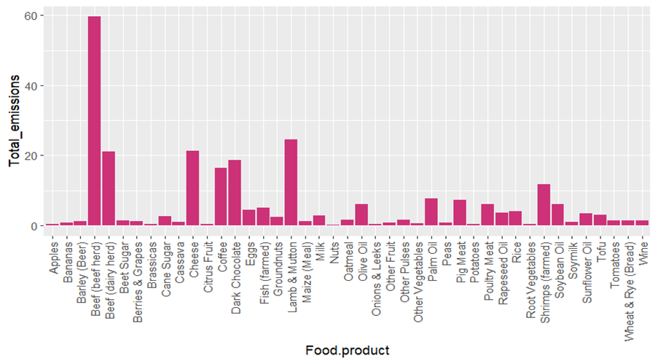

**For the following data there were not values provided for all food products.**

Eutrophication is the pollution of water bodies and ecosystems with excess nutrients. The runoff of nitrogen and other nutrients from agricultural production systems is a leading contributor. They are measured in grams of phosphate equivalents (PO₄eq). (Our World in Data (OWID))

In the eutrophying data, there are different top emitters depending on the units chosen. For emissions per kg of food product and 100g protein, the highest emitter was beef (dairy herd). For 1000kcal of food product it was coffee.

The highest freshwater withdrawals per kcal (liters per 1000kcal) were fish (farmed). If the withdrawals per grams of protein (liters per 100g protein) are used, the highest is for apples. If kilograms (liters per kilogram) are used, then the highest withdrawals are for cheese.

For the greenhouse gas emissions per different units of food product, coffee was the highest per kcal. For protein, dark chocolate was the highest.

For land use per kcal, beef (beef herd) was the highest and for per kg and protein, lamb and mutton were the highest.

Scarcity-weighted water is determined as freshwater use weighted by local water scarcity. Again, data is provided for different food units. Scarcity-weighted water use per kilogram (liters per kilogram) was highest for nuts. When per 100g protein was used instead it was highest for apples. When kcal were used, brassicas were the highest.

Some conclusions:

Animal based food products were the highest overall emitters of greenhouse gases. However, some animal products were lower than some plant based food products. For example, pig meat was lower than coffee and dark chocolate.

While analyzing the maximum greenhouse gas emissions for each of the different food production processes, the highest emissions came from farming.

When it comes to eutrophication, for units of kg and protein, the highest emitter was beef (dairy herd) and coffee for kcal. When considering water resources, for freshwater the highest withdrawals per kg came from cheese, per kcal it was farmed fish and per protein it was apples. When looking at water scarcity the highest impact was nuts per kg, brassicas per kcal and apples per g protein.

The lowest greenhouse gas emissions when comparing kcal of food product was for nuts, see graph below. Nuts were also the lowest in greenhouse gas emissions per 100g protein.

